**1.INTRODUCTION:**

**The Global air transportation network datasets is a comprehensive collection of information on airports, airlines and their routes. It contains information such as names, cities, countries, codes longitudes, latitudes, etc.**

* **Purpose:**

**Air transport allows people from different countries to cross international boundaries and travel other countries for personal, business, medical, and tourism purposes**.

* **Achieved:**

**High Speed, Fast service, Natural Route, High Standard of Security**.

**2. PROBLEM DEFINITION AND DESIGN THINKING:**

* **Empathy map:**

**An empathy map is a collaborative tool teams can use to gain a deeper insight into their customers.**

* **Ideation and brainstorming map:**

**This map Represent the problem leads in air transportation. Air travel is the riskiest mode of transport, since there can be considerable losses to goods, customer and crews as a result of a minor crash.**

1. **RESULT:**

* **EMPATHY MAP-MURAL:**

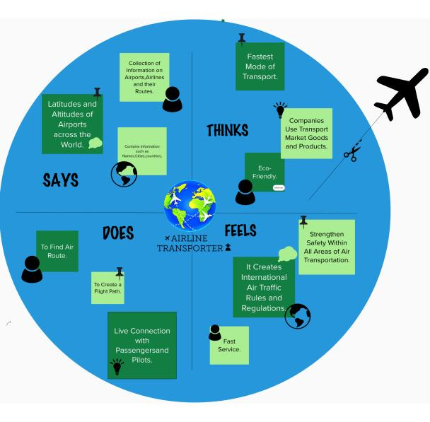

* **BRAINSTORMING: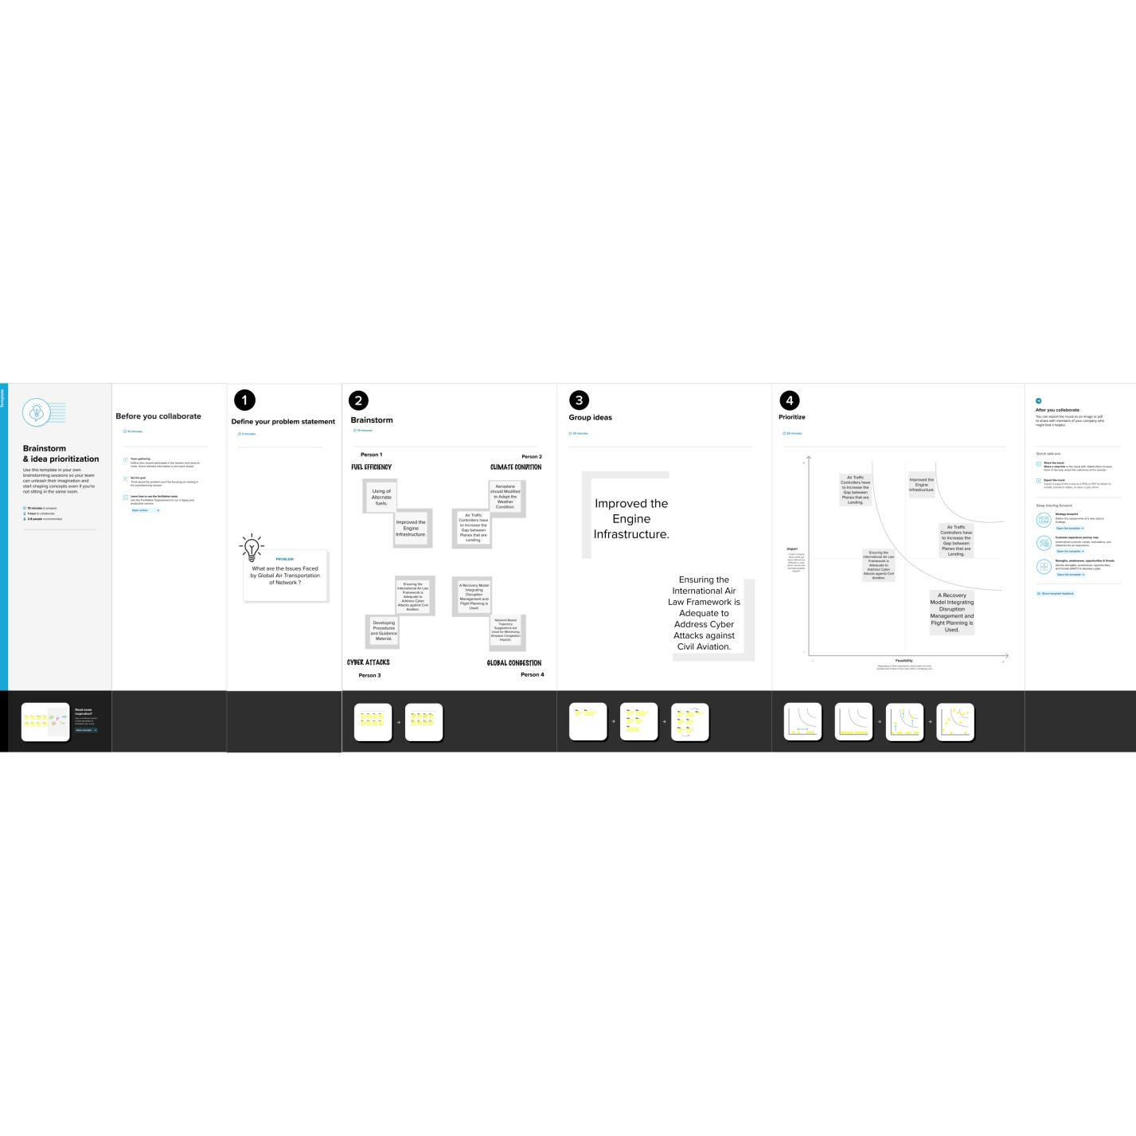TABLEAU SHEETS :**

**Sheet-1: Airports With Map.**

**Sheet-2: Number Of Airports.**

**Sheet-3: Airports With Higher Altitudes.**

**Sheet-4: Airlines With In A Country.**

**Dashboard-1: Map With Number Of Airports.**

**Dashboard-2: Airports with Higher Altitudes And Airlines Within a country.**

**Dashboard-3:Complete details Of Airports and Airlines.**

**SHEET-1:**

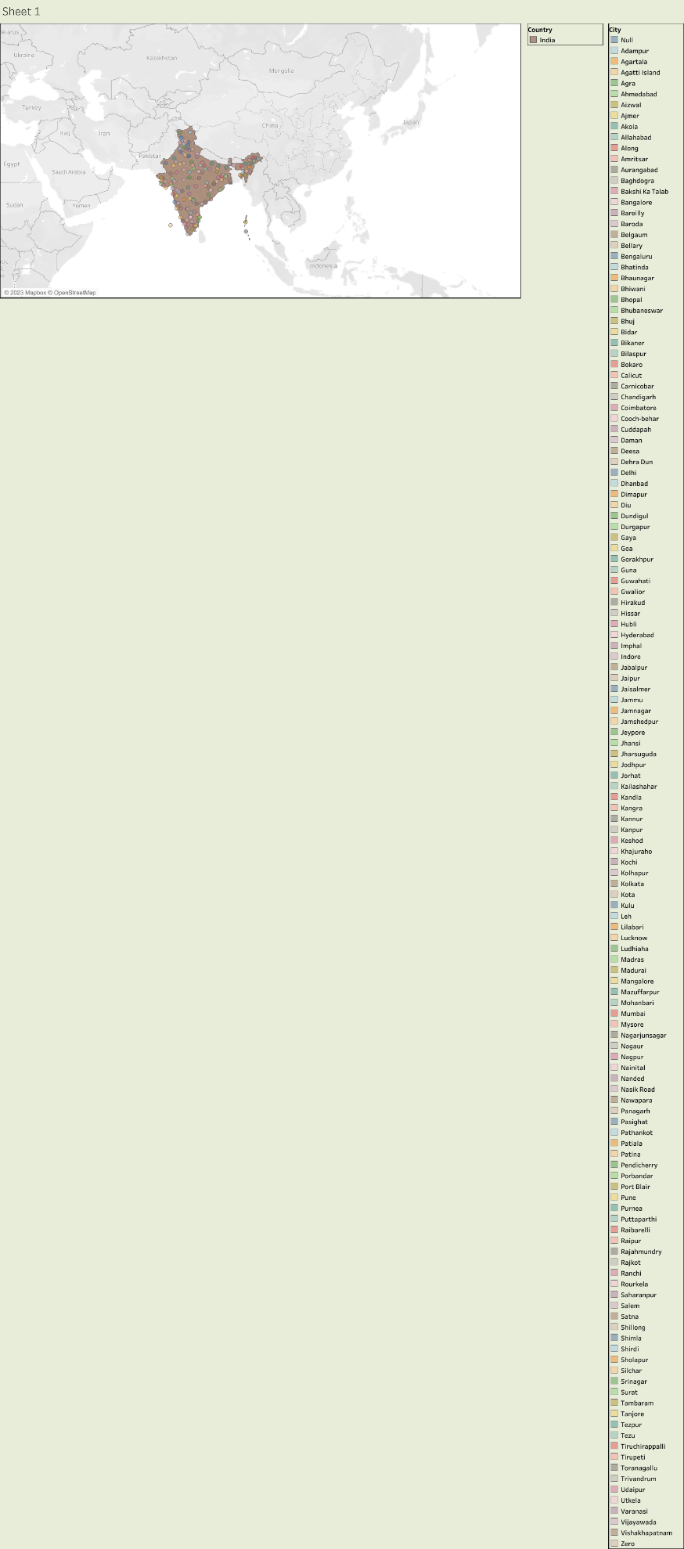

**SHEET 2:**

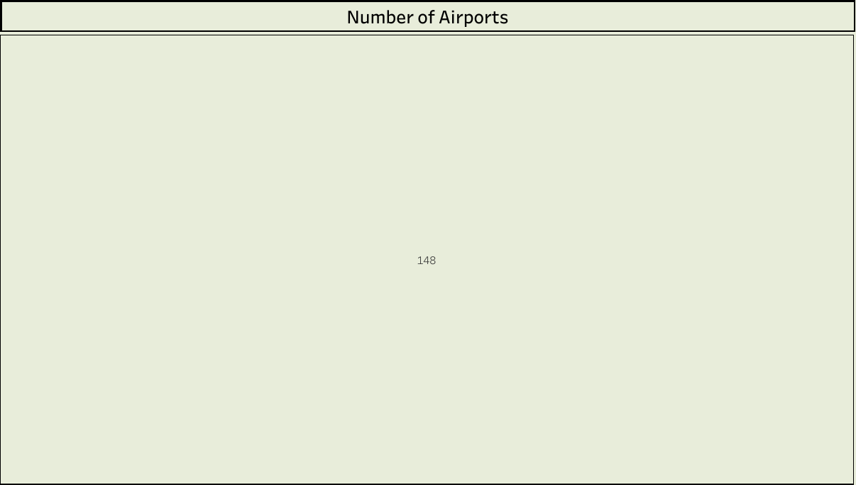

**SHEET-3:**

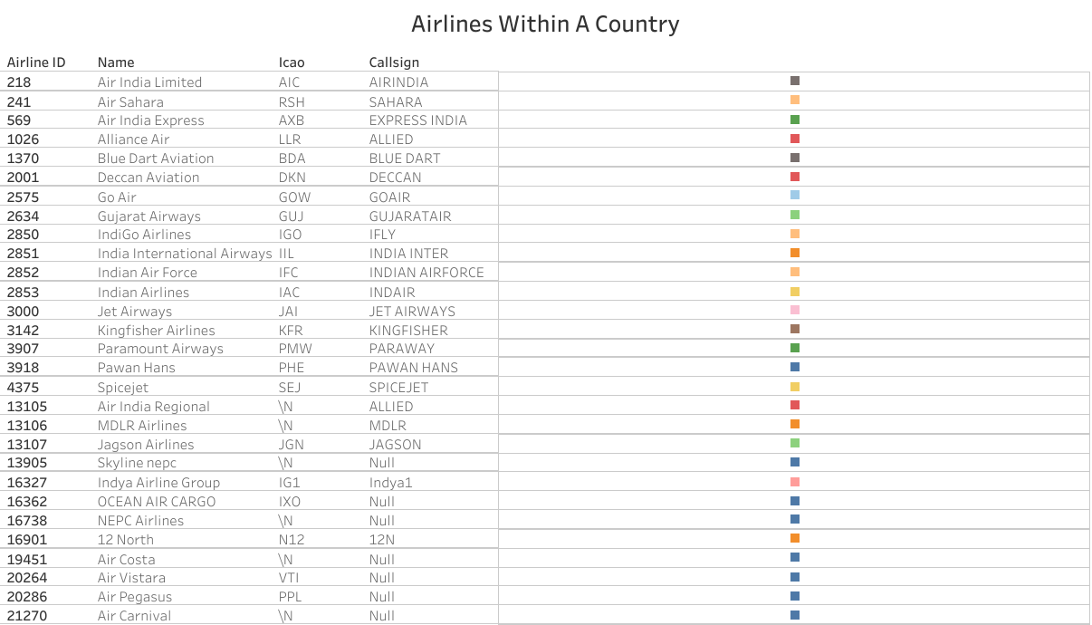

**SHEET-4:**

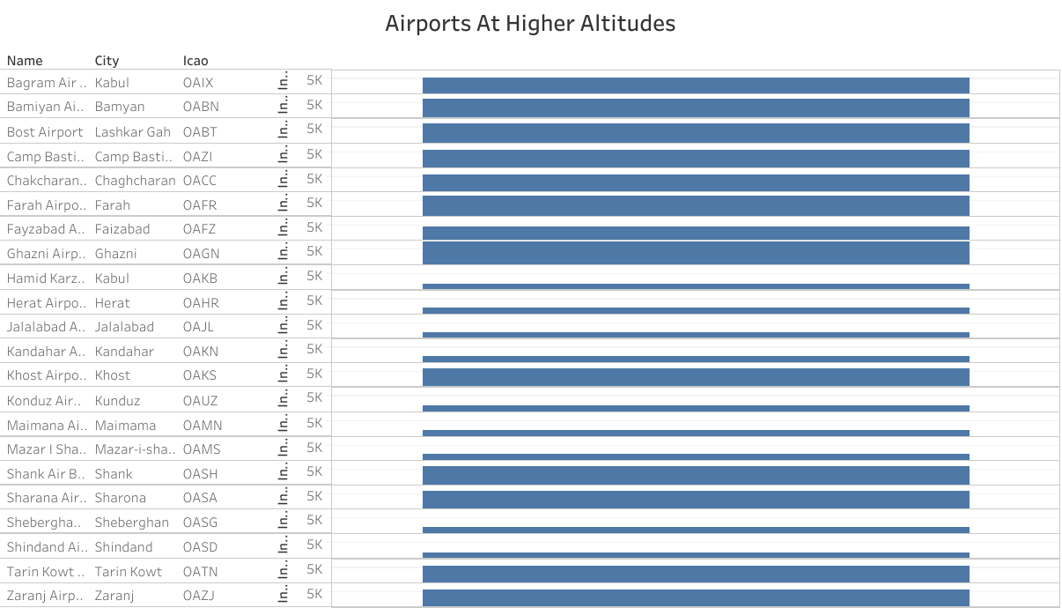

**DASHBOARD-1:**

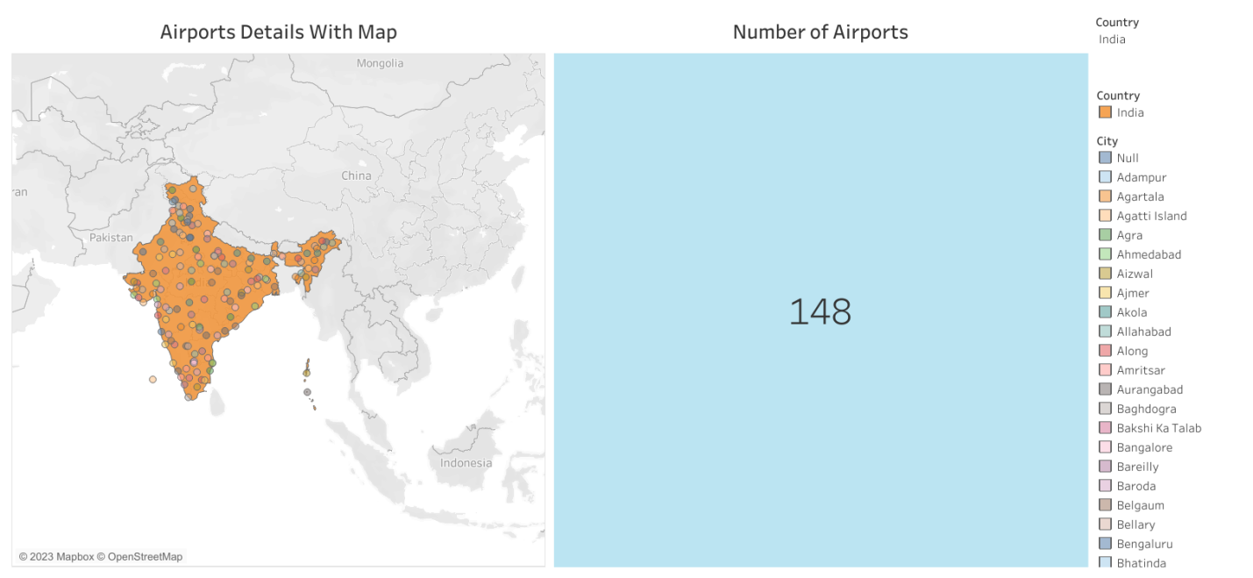

**DASHBOARD-2:**

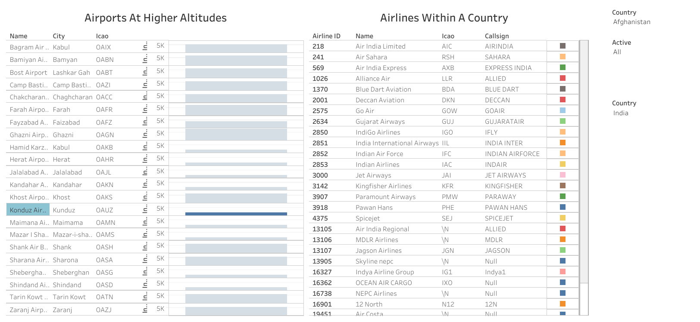

**DASHBOARD-3:**

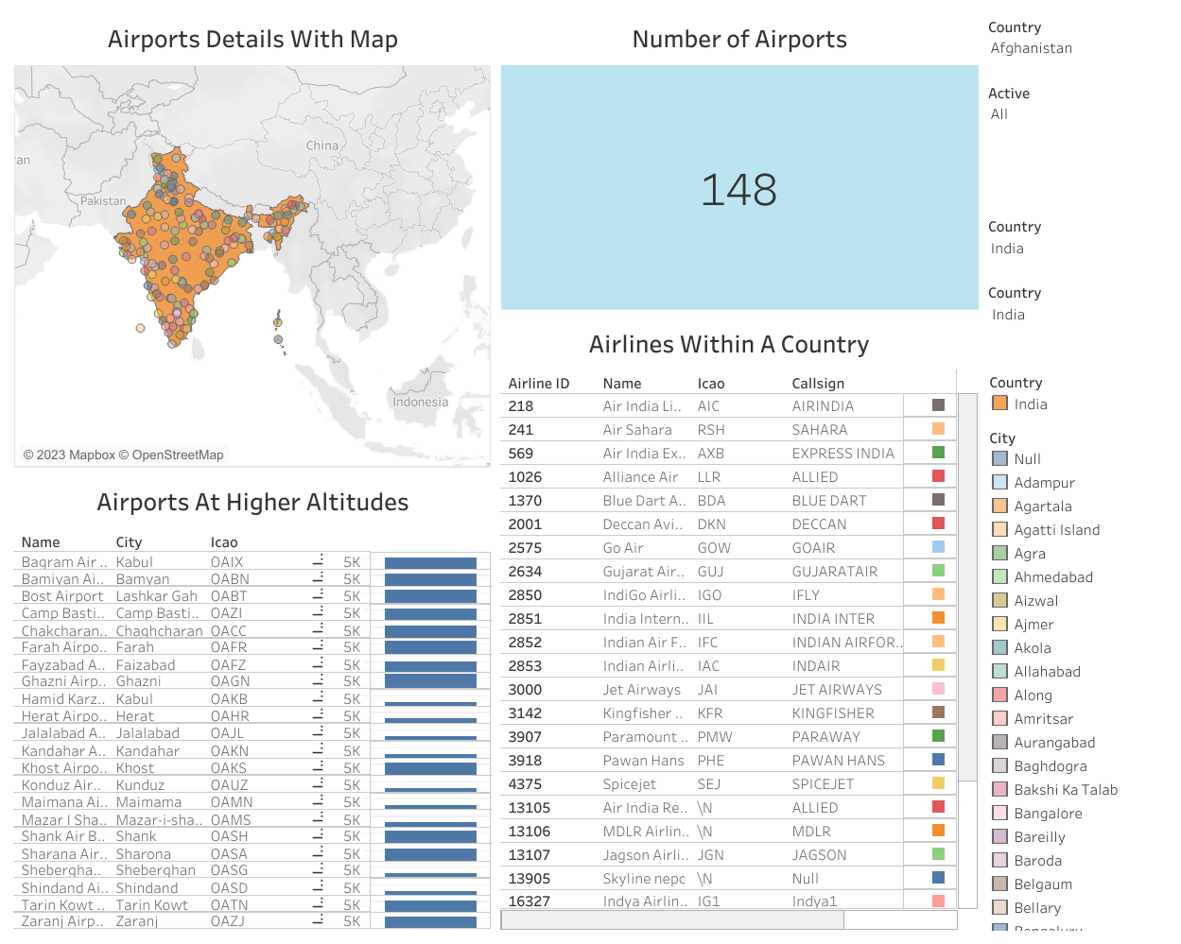

**STORY:**

**Airports Detail With Map: Number Of Airports:**

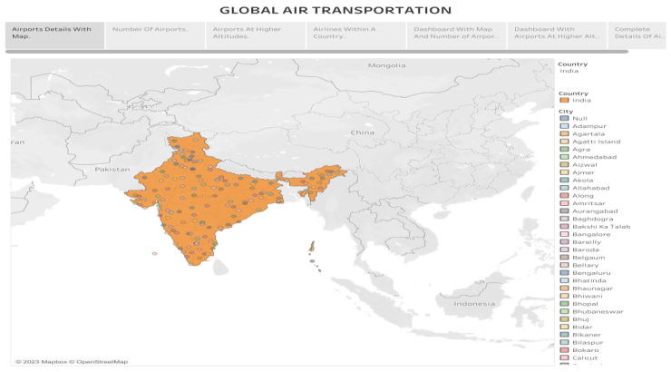 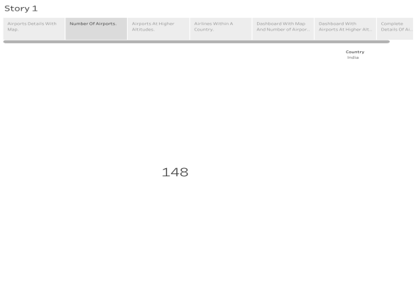

**Airports At Higher Airports: Airlines Within a Country:**

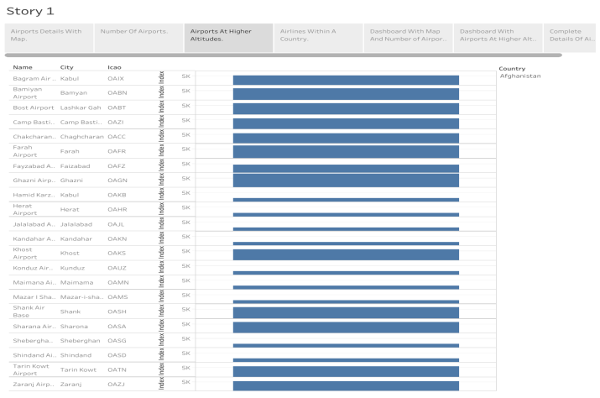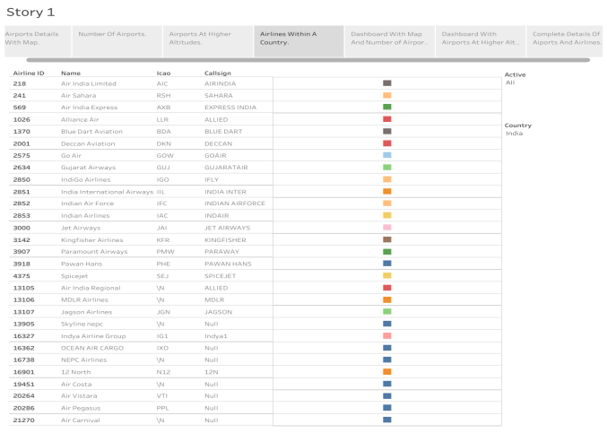

**Map with Number Of Airports: Airports And Airlines In A Country:** 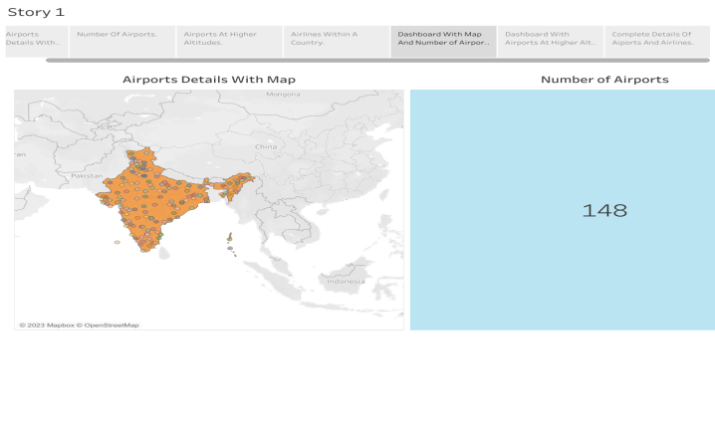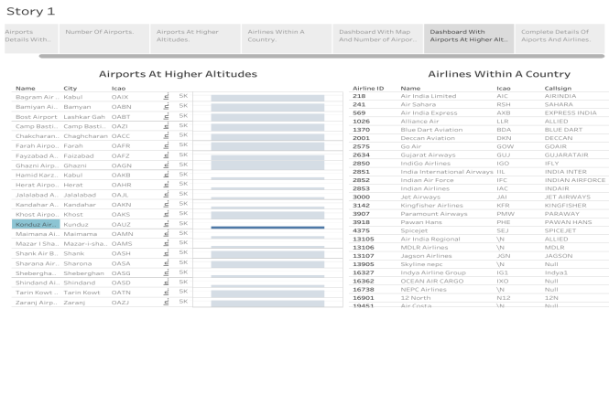

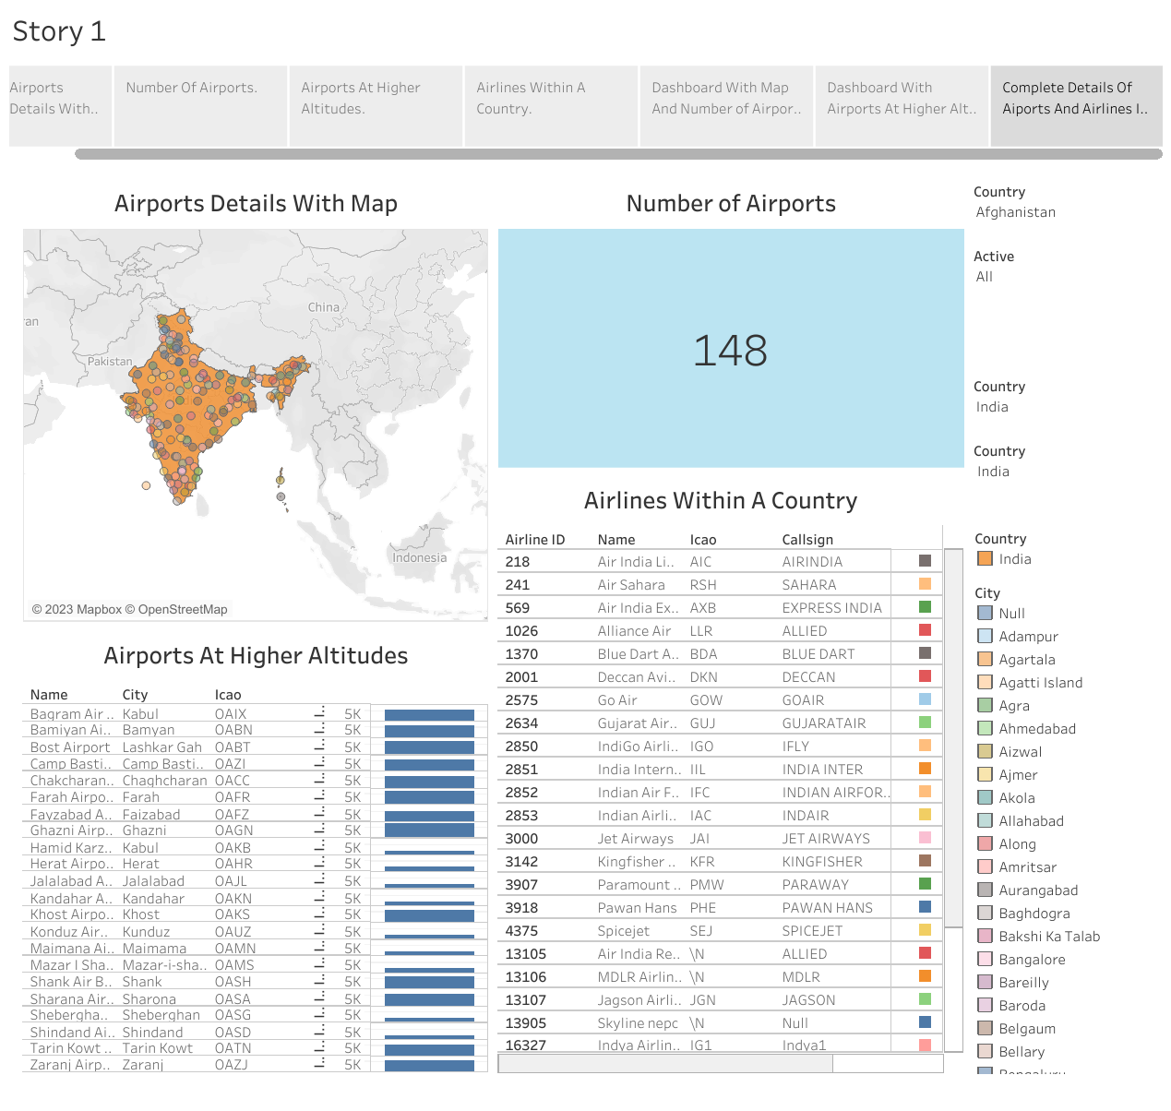

**4.ADVANTAGES AND DISADVANTAGES:**

* **Advantages:**

**Essential Services, Economic Growth, Employment, Social Connectivity, Tourism, Environmental Factor.**

* **Disadvantages:**

**Air Pollution, Noise Pollution, Congestion, Safety, Cost, Land-Related Concerns.**

**5.APPLICATION:**

* **Setting Up of Regulations.**
* **Use of Technology.**
* **Carbon Offsetting Programs.**
* **Using Alternative Means.**
* **Use of Computer Programs to Reduce Noise Pollution.**

**6.CONCLUSION:**

**The air transport system generally includes airports, ATC (air traffic control) system, and airlines. The airports represent the ground part of the system's infrastructure handling the aircraft operated by different airlines transporting passengers and freight/cargo shipments.**

**In conclusion, the Indian aviation industry has undergone significant developments and growth in recent years.**

**7.FUTURE SCOPE:**

**In 2023 airlines are set to tap into AI and predictive analytics for ultra-efficient aircraft operations that will carry us higher than we have flown before.**

**8.APPENDIX:**

**The demand for air travel depends on several factors, such as income, preferences, prices, substitutes and complementary goods.**